Ansible Task 4
- Create ansible playbook to create ansible vault.
- Write a ansible playbook to install apache in linux and ubuntu machine by using when condition.
- Create ansible playbook using roles to configure LAMP stack
- Setup ansible AWX and explore the options.

Task 1 — Create Ansible Vault using a playbook
Step 1: Create a new Vault automation playbook
We'll create create_vault.yml. This playbook will use Ansible's command module to create an encrypted Vault file. For safety, we'll use a separate output filename so your existing Vault variables remain untouched.
Run this command on your master:
cat > create_vault.yml <<'EOF'
---
- name: Create an encrypted Ansible Vault file
hosts: localhost
connection: local
gather_facts: false

vars:
vault_file: new_vault_vars.yml

tasks:
- name: Create Vault file if it does not exist
ansible.builtin.command:
cmd: ansible-vault create {{ vault_file }}
creates: "{{ vault_file }}"
EOF
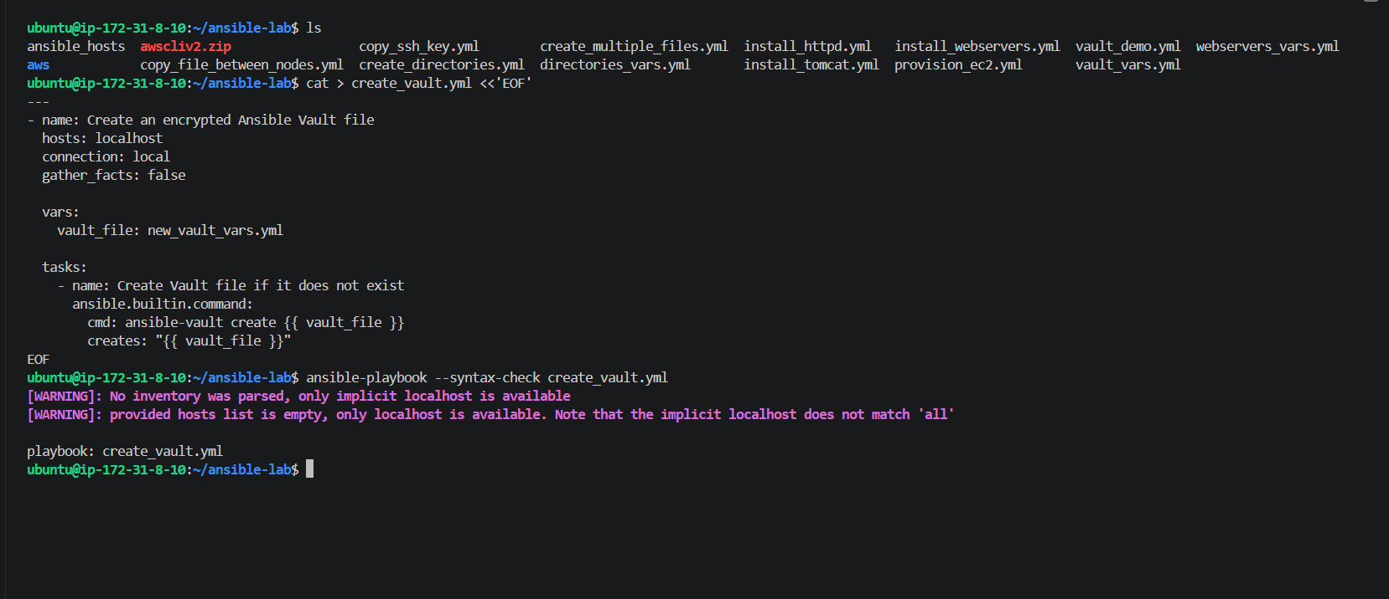
Step 2 — Create a plaintext template for the new Vault file
Run this command:
cat > new_vault_vars.yml.plain <<'EOF'
---
app_name: ansible-lab
environment: development
EOF
Step 3: Encrypt the new variables file
Let's encrypt the file you created in the previous step.
Run this command on your Ansible master:
ansible-vault encrypt new_vault_vars.yml.plain --output new_vault_vars.yml
After encryption, verify the first line:
head -n 1 new_vault_vars.yml
Expected output:
$ANSIBLE_VAULT;1.1;AES256
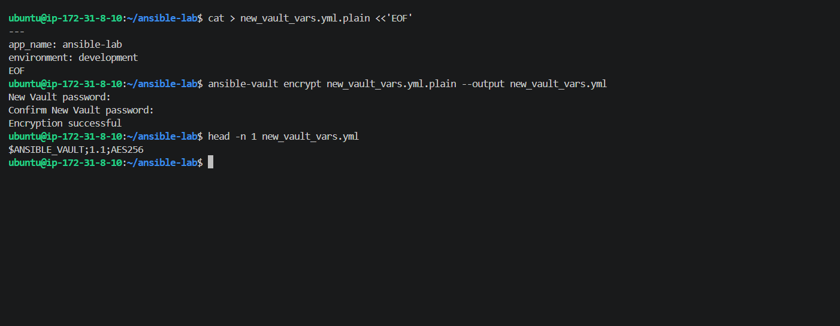
Step 4: Update the playbook to validate the Vault file
Now let's replace create_vault.yml with a playbook that checks whether the encrypted file exists and verifies its Vault header without exposing the secret.
Run this command:
cat > create_vault.yml <<'EOF'
---
- name: Validate Ansible Vault file
hosts: localhost
connection: local
gather_facts: false

vars:
vault_file: new_vault_vars.yml

tasks:
- name: Check that encrypted Vault file exists
ansible.builtin.stat:
path: "{{ vault_file }}"
register: vault_status

- name: Verify Vault file exists
ansible.builtin.assert:
that:
- vault_status.stat.exists
- vault_status.stat.isreg
success_msg: "Vault file exists."

- name: Read encrypted Vault header
ansible.builtin.command:
cmd: head -n 1 "{{ vault_file }}"
register: vault_header
changed_when: false

- name: Verify file is encrypted
ansible.builtin.assert:
that:
- vault_header.stdout.startswith('$ANSIBLE_VAULT;')
success_msg: "Vault file is encrypted successfully."
EOF
EOF
Then run the syntax check:
ansible-playbook --syntax-check create_vault.yml

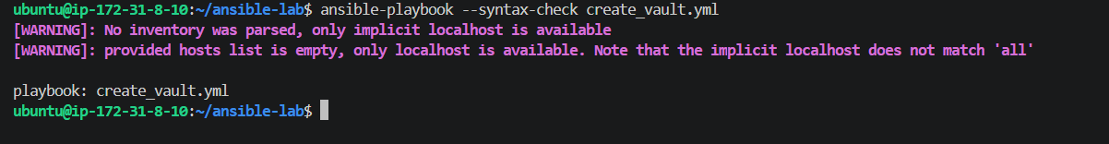
Step 5: Execute the playbook
Run:
ansible-playbook create_vault.yml
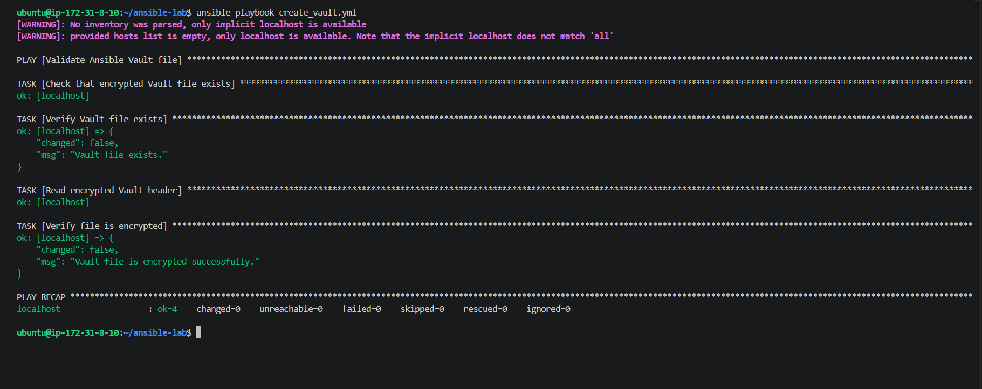
Task 2 — Install Apache on Linux and Ubuntu using when
We'll use your existing two Ubuntu workers and Ansible's OS facts to select the appropriate installation task. We'll also make the playbook support Red Hat-based Linux distributions.
Step 1 — Create the playbook
Run this on your Ansible master:
cat > install_apache_when.yml <<'EOF'
---
- name: Install Apache based on operating system
hosts: workers
become: true
gather_facts: true

tasks:
- name: Install Apache on Ubuntu or Debian
ansible.builtin.apt:
name: apache2
state: present
update_cache: true
when: ansible_os_family == "Debian"

- name: Install Apache on Red Hat Linux
ansible.builtin.dnf:
name: httpd
state: present
when: ansible_os_family == "RedHat"

- name: Start and enable Apache on Ubuntu or Debian
ansible.builtin.service:
name: apache2
state: started
enabled: true
when: ansible_os_family == "Debian"

- name: Start and enable Apache on Red Hat Linux
ansible.builtin.service:
name: httpd
state: started
enabled: true
when: ansible_os_family == "RedHat"
EOF
Step 2 — Check the syntax
ansible-playbook -i ansible_hosts --syntax-check install_apache_when.yml
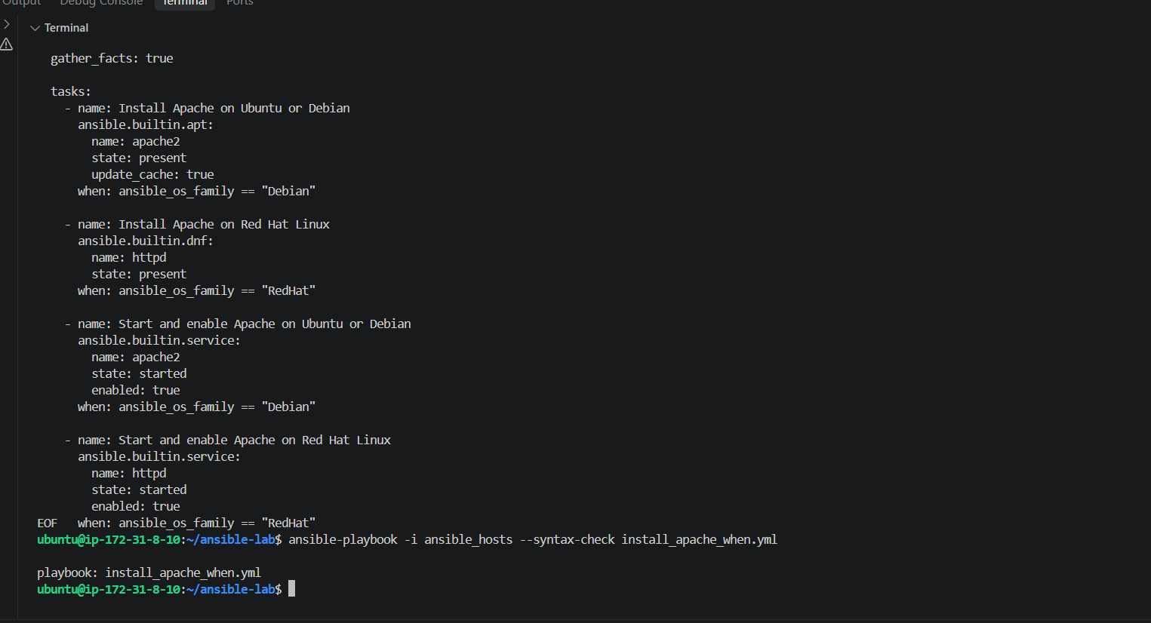
Task 2 — Step 2: Run the playbook
Execute this command on your Ansible master:
ansible-playbook -i ansible_hosts install_apache_when.yml
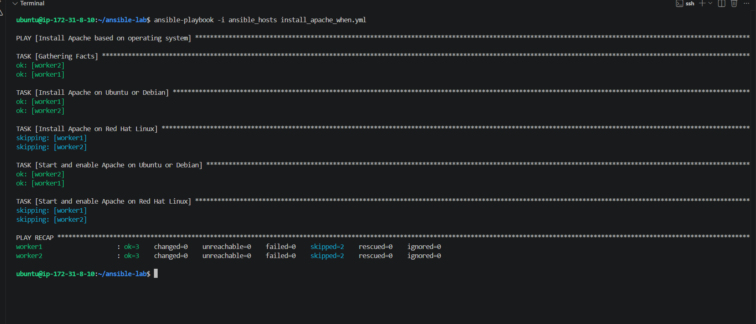
Task 3 — Configure a LAMP stack using Ansible roles
LAMP stands for:
- L — Linux
- A — Apache
- M — MySQL/MariaDB
- P — PHP
We'll organize the configuration into reusable roles rather than putting every task into one large playbook.
Step 1 — Create the role directory structure
Run this command on your Ansible master inside ~/ansible-lab:
mkdir -p roles/lamp/{tasks,handlers,templates,defaults}
Then verify the structure:
find roles/lamp -maxdepth 2 -type d
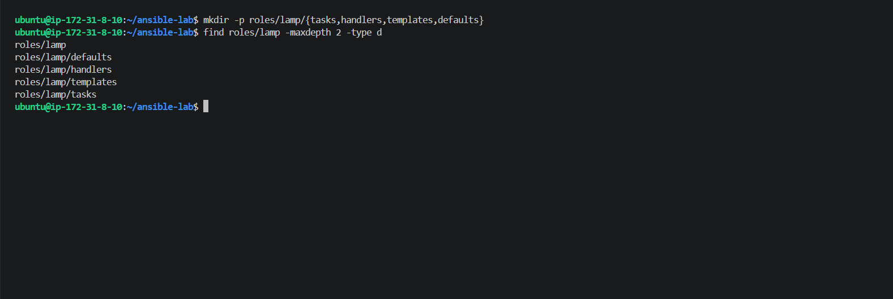
Step 2: Define the default variables
We'll use Ubuntu-compatible packages: Apache (apache2), MariaDB (mariadb-server), and PHP (php, libapache2-mod-php, php-mysql).
Create the role defaults file:
cat > roles/lamp/defaults/main.yml <<'EOF'
---
lamp_packages:
- apache2
- mariadb-server
- php
- libapache2-mod-php
- php-mysql

lamp_service_names:
- apache2
- mariadb
EOF
Now verify the file:
cat roles/lamp/defaults/main.yml
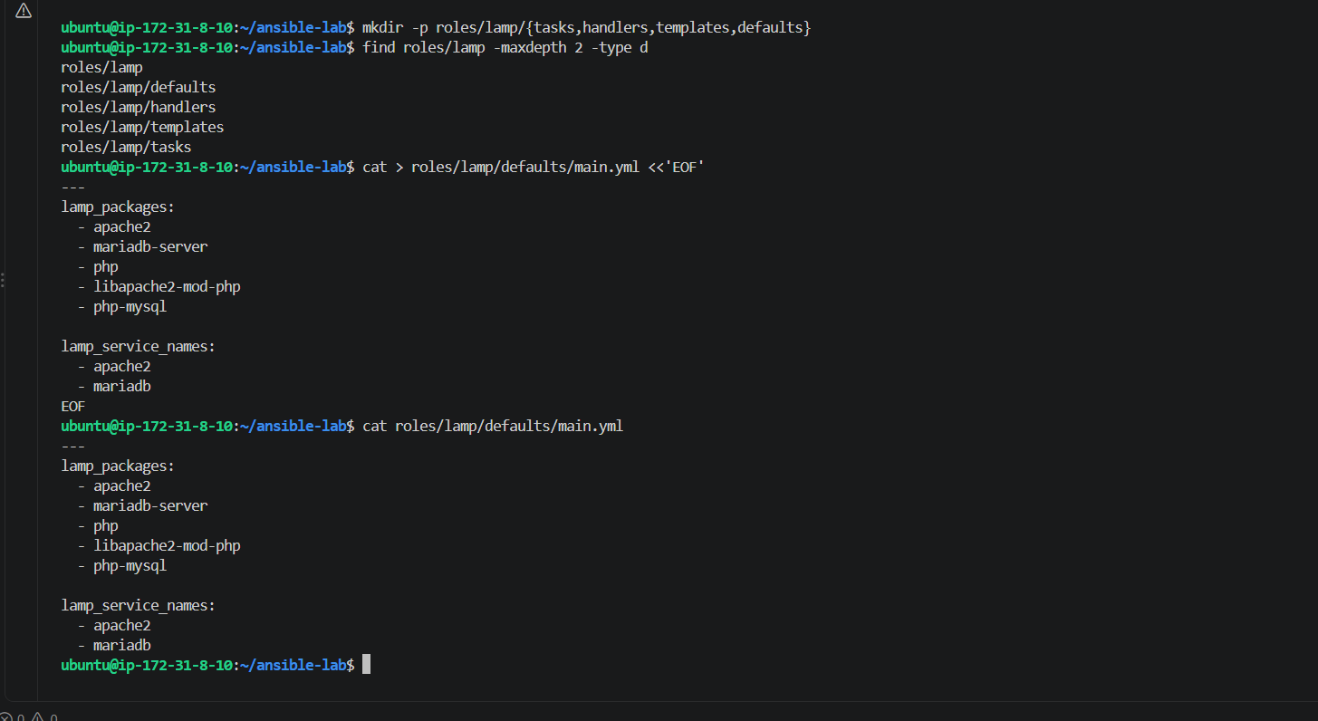
Step 3: Create the LAMP installation tasks
Now create roles/lamp/tasks/main.yml. These tasks will install Apache, MariaDB, and PHP, then start and enable the required services.
Run this command on your master:
cat > roles/lamp/tasks/main.yml <<'EOF'
---
- name: Install LAMP packages
ansible.builtin.apt:
name: "{{ lamp_packages }}"
state: present
update_cache: true

- name: Ensure Apache and MariaDB are enabled and running
ansible.builtin.service:
name: "{{ item }}"
state: started
enabled: true
loop: "{{ lamp_service_names }}"

- name: Deploy PHP test page
ansible.builtin.copy:
dest: /var/www/html/info.php
content: |
<?php
echo "<h1>LAMP Stack Installed Successfully</h1>";
echo "<p>PHP is working on this server.</p>";
?>
owner: root
group: root
mode: '0644'
notify: Restart Apache
EOF
Step 4: Create the Apache handler
A handler runs only when a task notifies it. In our LAMP role, Apache will restart when the PHP test page changes.
Run this command on your Ansible master:
cat > roles/lamp/handlers/main.yml <<'EOF'
---
- name: Restart Apache
ansible.builtin.service:
name: apache2
state: restarted
EOF
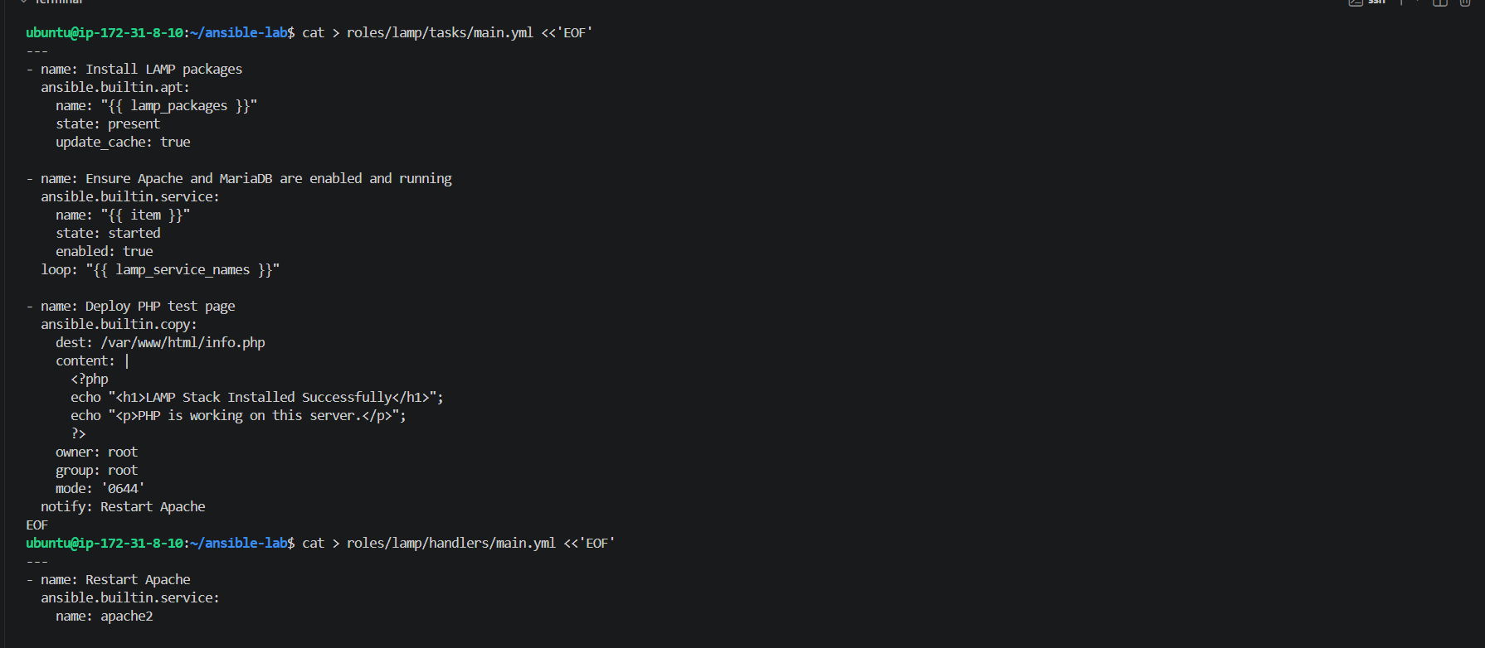
Now verify the handler file:
cat roles/lamp/handlers/main.yml
Expected content:
---
- name: Restart Apache
ansible.builtin.service:
name: apache2
state: restarted
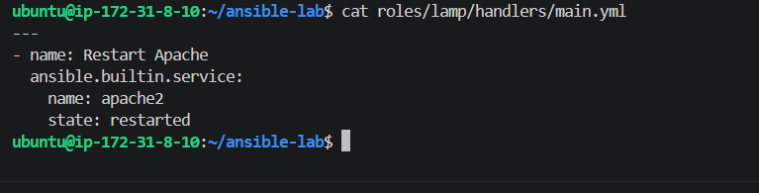
Step 5: Create the main LAMP playbook
Now we'll call the lamp role on both workers.
Run this command on your Ansible master:
cat > lamp_stack.yml <<'EOF'
---
- name: Configure LAMP stack using Ansible role
hosts: workers
become: true
gather_facts: true

roles:
- lamp
EOF
Next, check the playbook syntax:
ansible-playbook -i ansible_hosts --syntax-check lamp_stack.yml
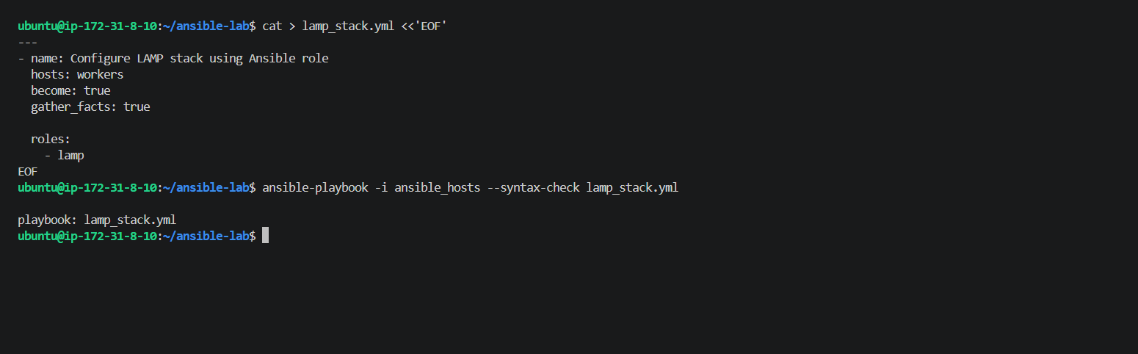
Step 6: Run the LAMP role
Run this command on your Ansible master:
ansible-playbook -i ansible_hosts lamp_stack.yml
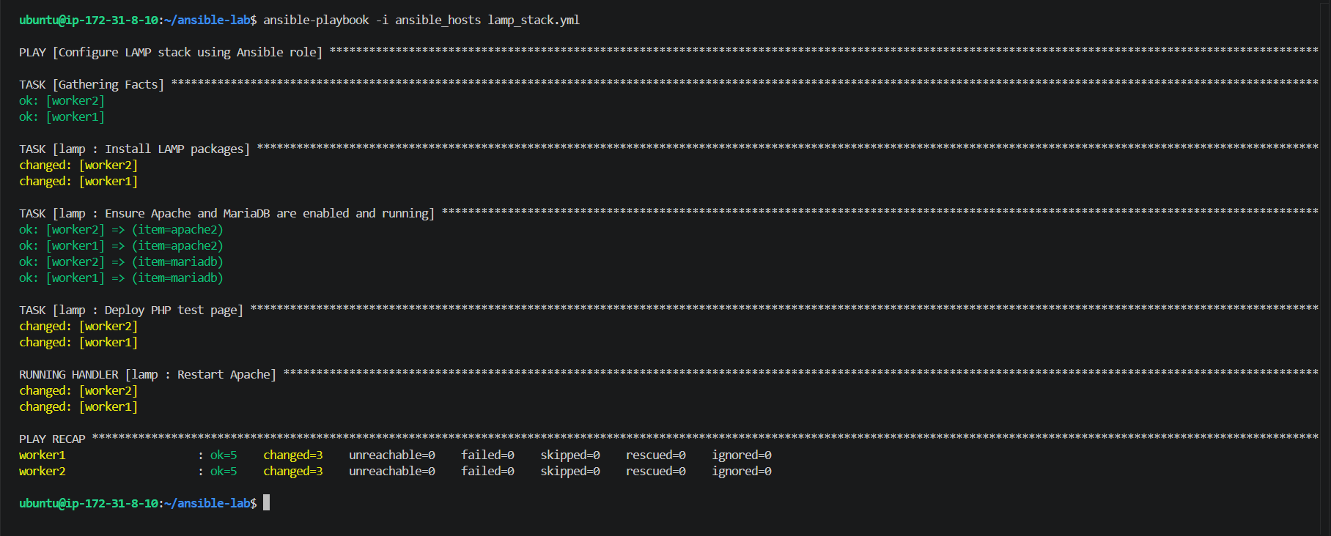
Step 7 — Verify the LAMP stack
Run this command on your Ansible master:
ansible workers -i ansible_hosts -b -m shell -a "systemctl is-active apache2 mariadb && php -v | head -n 1 && test -f /var/ww
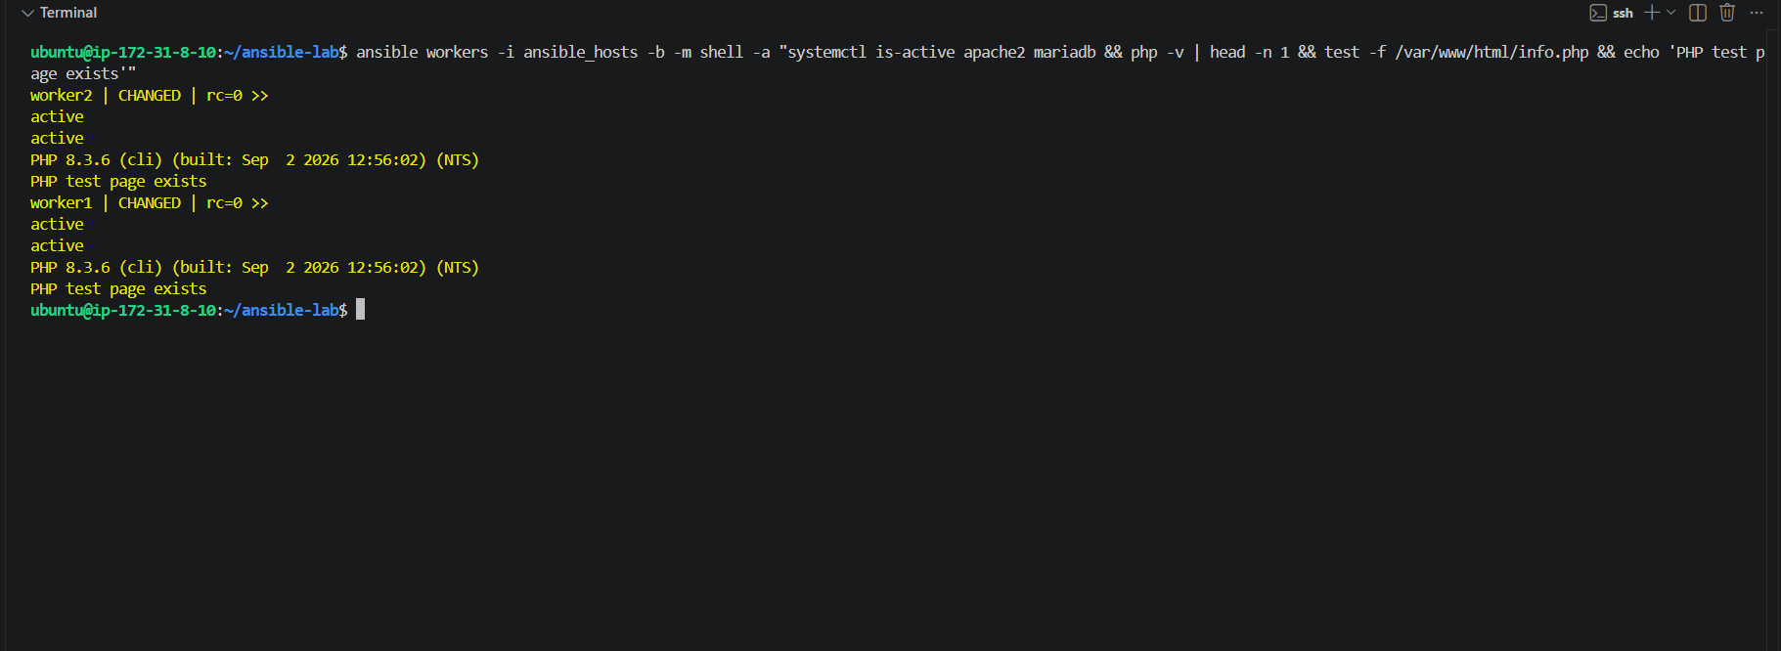
Step 8 — Test the PHP page over HTTP
Run this command on your Ansible master:
ansible workers -i ansible_hosts -m uri -a "url=http://127.0.0.1/info.php return_content=true"
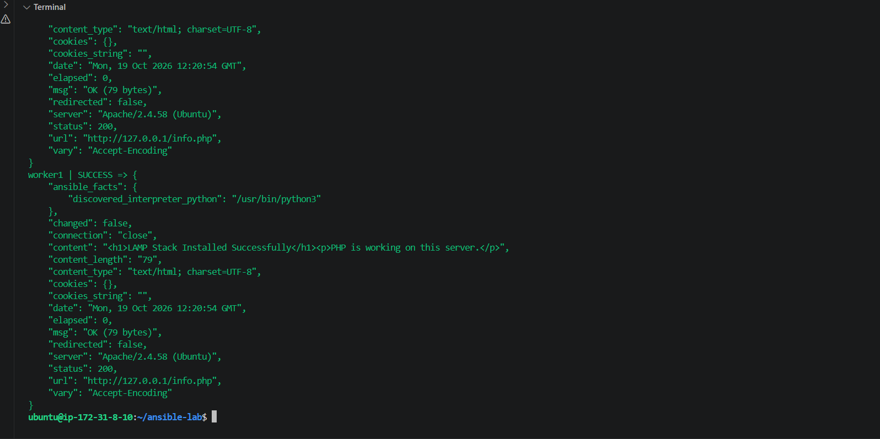
Task 4 — Set up Ansible AWX and explore its options
AWX is the web-based interface and task engine for Ansible. It lets you manage inventories, credentials, projects, job templates, and playbook execution from a dashboard.
Before installation, let's check whether your existing master has enough resources. AWX is considerably heavier than basic Ansible, so we should avoid overloading your t3.micro instance.
Step 1 — Check master resources
Run this command on your master:
free -h && df -h / && nproc && docker --version
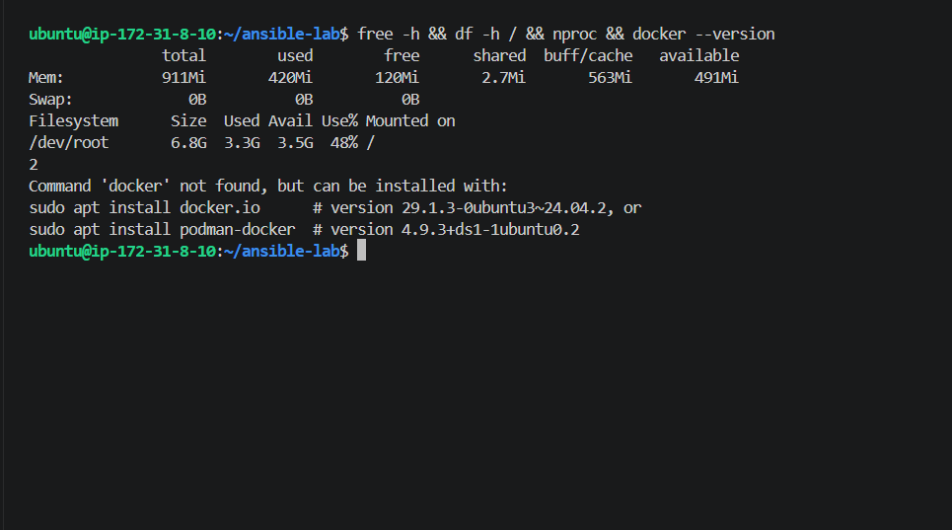
Step 1 — Check your EC2 vCPU quota
Run this on your master:
aws service-quotas get-service-quota \
--service-code ec2 \
--quota-code L-1216C47A \
--region ap-south-1 \
--query 'Quota.{Name:QuotaName,Value:Value}' \
--output table
